


Computer Communications 25 (2002) 1699–1710

www.elsevier.com/locate/comcom

Accurate bandwidth measurement in xDSL service networks

Liang Cheng*, Ivan Marsic

Department of Electrical and Computer Engineering and the CAIP Center, Rutgers, The State University of New Jersey, Piscataway, NJ 08854-8088, USA
Received 14 May 2001; revised 6 February 2002; accepted 27 February 2002

Abstract
In xDSL service networks, accurate bandwidth measurement is essential for network management and trafﬁc engineering, such as isolating
line faults and verifying guaranteed quality of service speciﬁcations, where ISP and xDSL service providers may be involved. Existing
Internet bandwidth measurement techniques are not suitable because link asymmetry and ATM trafﬁc shaping in xDSL deployments impact
the accuracy of their measurements. In this paper, we present a novel stepwise algorithm for bandwidth measurement that performs
accurately in xDSL service networks. The stepwise algorithm requires a smooth trafﬁc generator since otherwise the accuracy would be
affected by the ATM trafﬁc shaping. A multi-packet technique is used to avoid explicit packet ﬁltering. The scheme is lightweight in terms of
implementation complexity and probe trafﬁc overhead. The accuracy of the algorithm is demonstrated by laboratory and ﬁeld experiments.
The results show that the measurement errors in both upstream and downstream cases are within the range of 5% in a commercial ADSL
service network tested under the following ATM network conﬁgurations: CBR, rt-VBR, and UBR service categories. q 2002 Elsevier
Science B.V. All rights reserved.
Keywords: xDSL networks; Bandwidth measurement; Asymmetric networks; ATM trafﬁc shaping

1. Introduction

The growth in deployment of Internet applications
requiring high bandwidth has created a need for faster
local loops for users connecting to the Internet through a
dial-in Internet Service Provider (ISP). In most cases, a
serial modem solution, which offers a maximum bandwidth
of up to 56 Kbps, is not sufﬁcient. Therefore, various
technologies, such as Digital Subscriber Line (DSL) and
cable modems, have emerged to achieve high-speed
local-loop connectivity to the Internet. Local phone
companies in the United States have been installing
commercial xDSL lines since 1998. xDSL refers to
different variations of DSL, such as Asymmetric DSL
(ADSL), Symmetric DSL (SDSL), High bit-rate DSL
(HDSL), Rate Adaptive DSL (RADSL), and Very High-
speed DSL (VDSL) [22]. xDSL has several advantages
compared to other access technologies [9]: (i) its initial
cost can be predicted and spent only when a customer
requests the service, (ii) it requires no change to the
central ofﬁce switch software, (iii) it can interface with
a number of different premises arrangements, (iv) a

* Corresponding author. Tel.: ю 1-732-445-0660; fax: ю 1-732-445-4775.
E-mail addresses: chengl@caip.rutgers.edu (L. Cheng),
marsic@caip.rutgers.edu (I. Marsic).

DSL line can simultaneously carry both data and voice
signals with the data part of the line continuously
connected. In addition, xDSL can be used for residential
users, Small Ofﬁce, Home Ofﬁce (SOHO) users, and
large organizations because of its wide range of service
rates. For example, ADSL enables receiving data at
rates up to 6.1 Mbps (of a theoretical 8.448 Mbps).
Typical ADSL connection services provide from
512 Kbps to 1.544 Mbps downstream (from service
provider to customer, or from Central Ofﬁce to Customer
Premises) and about 64 – 128 Kbps upstream. The down-
stream speeds of VDSL range from 13 to 55 Mbps
depending on distance, while its upstream speeds start at
1.5 Mbps and go up to about 26 Mbps [9].
The xDSL deployment architecture in the ADSL case is
abstracted in Fig. 1. The customer’s premises equipment is
an ADSL Termination Unit—Remote (ATU-R) or an ADSL
modem. An ADSL Termination Unit—Central Ofﬁce
(ATU-C) is located at a Central Ofﬁce end of the phone
company that provides the xDSL service. The ATU-Cs are
grouped into a DSL Access Module (DSLAM) unit that
terminates the multiplexed trafﬁc into an ATM switch. In
some cases, an IP router can be used instead of the ATM
switch depending on budget constraints. However, the
performance aspects of ATM networks and services justify
the use of ATM switches [9]. In the ﬁeld experiments

0140-3664/02/$ - see front matter q 2002 Elsevier Science B.V. All rights reserved.
PII: S 0 1 4 0 - 3 6 6 4 ( 0 2 ) 0 0 1 0 4 - 4

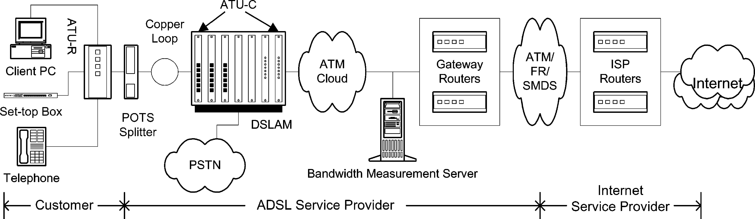

1700

L. Cheng, I. Marsic / Computer Communications 25 (2002) 1699–1710

Fig. 1. xDSL deployment architecture (ADSL case).

reported here, an ATM switch is used. The ATU-C
terminates multiple subscriber loops and connects the
ATU-R to the Internet through a Gateway Router. The
deployment and maintenance of the line between the ATU-
R and the Gateway Router is the responsibility of the phone
company and there is a need to measure the actual physical
line speed of the ADSL link for reasons explained below.

1.1. Motivation for accurate bandwidth measurement

In addition to general beneﬁts that can be gained by
measuring network link bandwidth, such as application
adaptation to network conditions [17], there are speciﬁc
motivations for accurate bandwidth measurement in xDSL
service networks. In this paper, we study the link bandwidth
measurement, which is the smallest bandwidth (bottleneck-
link bandwidth) along the xDSL data path in the xDSL
service network. (The xDSL service network, or ‘xDSL
network,’ refers to the customer and the ADSL service
provider parts in Fig. 1 and does not include the ISP part.) It
can also be the case that applications themselves might be
interested in available bandwidth, given that several
applications are simultaneously using the same pipe,
however, this is not studied here.
Commercial xDSL networks combine the beneﬁts of the
Discrete Multi-Tone (DMT) or Carrierless Amplitude Phase
(CAP) modulation and ATM technologies, which result in
bandwidth and service ﬂexibility. For example, in ADSL
service networks upstream and downstream bit rates can be
chosen freely and quasi-continuously up to the maximum
physical limits. Based on the maximum possible bit rate
(with a predetermined margin), the service management
system of an xDSL network can set the bit rate to the level
determined by the customer’s service proﬁle, thus max-
imizing noise margin and/or minimizing transmit power. In
addition, xDSL networks can support a random mix of
services with different bit rates and trafﬁc requirements,
which are introduced on a per-customer basis.
Accurate bandwidth measurement in xDSL service
networks is essential for service provisioning. For example,
customers experiencing slow Internet-connection speeds
may want to know what the exact service parameters are. In
this case, a bandwidth measurement tool can help the
customers and the service providers (both the ISP and the
xDSL providers) to verify service quality. Accurate
bandwidth measurement thus contributes to better customer
service. For example, it can help customers identify which
xDSL category is the most appropriate for them. They can
determine whether ADSL is sufﬁcient or whether SDSL is
needed.
Accurate bandwidth measurement is important for net-
work management in xDSL networks, such as isolating line
faults and performing trafﬁc engineering. How xDSL
networks should be tested, repaired, and managed is in
fact an outstanding issue in the provisioning of xDSL
services [9]. From the network administrator’s point of
view, trafﬁc loads can be balanced knowing the bandwidths
in xDSL networks. Lastly, accurate bandwidth measure-
ment is helpful for xDSL-network design. Once a bottleneck
link is identiﬁed, extra capacity can be added to enhance the
network performance.

1.2. Related work

A number of techniques exist for bandwidth measure-
ment. Most of these can be categorized into two groups [16].
One group is a variant of pathchar [7,11,12] based on the
one-packet model. The disadvantage of this group is the
heavy overhead in bandwidth consumption. The other is a
variant of packet-pair [3,4,17,20,21] based on the packet-
pair model. This group imposes lower overhead compared
to the ﬁrst group.
In Ref. [16], a multi-packet model is presented to unify
the one-packet and the packet-pair model and a packet-
tailgating technique tailgater is proposed. However, as
pointed out in Ref. [15], similar to pathchar, the tailgater
measures individually the bandwidth of each link along a
path, which can be time-consuming and unnecessary for
applications that only want to know the bottleneck
bandwidth such as the xDSL case studied here.
Our focus is on xDSL networks and the common
disadvantage of the existing techniques is that their
accuracy is not satisfactory for xDSL service provisioning
since their error range is greater than 5%, and sometimes
10%. This is mainly due to ATM trafﬁc shaping in xDSL
service networks as explained in Section 2.2. For example,

L. Cheng, I. Marsic / Computer Communications 25 (2002) 1699–1710

1701

Ref. [15] reports that nettimer has a measurement error
greater than 10% of the nominal ADSL link bandwidth.
In addition to bandwidth measurement, the related
throughput measurement techniques have been used in
applications and protocols, such as Network Weather
Service (NWS) [23] and TCP. However, these techniques
are likewise not accurate and not suitable for bandwidth
measurement in xDSL networks. For example, during each
measurement in NWS [23], the round-trip time of a single-
word packet in a TCP connection is measured and the
resulting value is divided by two to yield an approximation
of the latency or start-up overhead associated with the
communication. Obviously, the approximation is not correct
in ADSL’s asymmetric case. The approximation is rough
without considering the ﬂow and congestion control by
TCP. There is also ongoing research [6] addressing
problems in bandwidth measurement caused by the ATM
network model and link asymmetry. However, no public
information is available as of now.
In theory, the one- or two-packet techniques and the
tailgating technique can get good estimation of xDSL link
bandwidth. However, the existing tools do not regulate the
probe packets so that ATM trafﬁc shaper will regulate the
probe packets for them by packet delay or packet drop. One
possible solution is to explicitly regulate the probe trafﬁc,
but then it is difﬁcult to specify the source rate. That is why
we propose a stepwise scheme: in the ﬁrst step we get a
rough estimate of the bandwidth and regulate the subsequent
probe trafﬁc according to the estimate. We also use multi-
packet technique to avoid explicit packet ﬁltering.
In our research, we designed an accurate bandwidth
measurement scheme for xDSL service network,
implemented it as a Java-based tool, and tested it in both
laboratory and commercial setup experiments. The accuracy
is achieved by implementing a novel stepwise bandwidth
measurement algorithm with an original trafﬁc generator for
smooth trafﬁc ﬂow and a multi-packet bandwidth measure-
ment technique. The experiments reported in this paper
demonstrate the accuracy of our measurement scheme.
The primary concern of this paper is the measurement
accuracy which is essential for xDSL service provisioning.
Other concerns could be imposed by protocol or layer
constraints (it may be required to use certain protocol, such
as TCP, User Datagram Protocol (UDP), ICMP, etc.) or by
packet type constraints (it may be required to use payload
packets for measurement, as opposed to probe packets
which add overhead trafﬁc). We are not considering those
concerns here, but we are using transport layer ﬂows. The
advantage of using transport layer ﬂows, e.g. a UDP packet
ﬂow, is that they can penetrate Network Address Translation
(NAT) gateways, which are more and more used in xDSL
deployments.
The paper is organized as follows. Section 2 discusses
ATM trafﬁc shaping and its effect on the accuracy of
bandwidth measurement. Section 3 introduces a multi-
packet bandwidth measurement technique and its appli-

cations to ADSL. Section 4 presents a stepwise algorithm
for accurate bandwidth measurement using a trafﬁc
generator with stable and accurate performance. Section 5
presents the evaluation results and Section 6 concludes the
paper.

2. ATM trafﬁc shaping

xDSL deployments are typically implemented over ATM
to provide different service qualities. For example, the
ATU-Cs in ADSL networks are grouped into a DSLAM unit
that terminates the multiplexed trafﬁc into an ATM switch
(Fig. 1). Based on the synchronization speed of the ADSL
modem, the ATM switch sets the service class for the virtual
circuit as the class to which a particular customer has been
mapped.
There are ﬁve service categories/classes in ATM net-
works speciﬁed by the ATM Forum [1]: Unspeciﬁed Bit
Rate (UBR), Available Bit Rate (ABR), Constant Bit Rate
(CBR), Real-Time Variable Bit Rate (rt-VBR), and Non-
Real-Time Variable Bit Rate (nrt-VBR) services. UBR
service does not have any guarantee with regard to the
quality of service (QoS) such as delay, loss or bandwidth.
No trafﬁc management is performed in the ATM layer for
the UBR service class, so the applications using UBR
service should be able to handle the ﬂuctuations in these
parameters by using error-correction and ﬂow control
techniques. ABR service guarantees only the cell-loss rate
(CLR), which is achieved by exchanging resource manage-
ment cells between the source and sink ATM nodes. CBR
service class is suitable for applications having strict QoS
requirements in delay and loss because it guarantees that a
static amount of bandwidth is always available to an
accepted connection. It is characterized by Peak Cell Rate
(PCR) and Cell Delay Variation Tolerance (CDVT). In
rt-VBR and nrt-VBR service classes, PCR, CDVT,
Sustained Cell Rate (SCR), and Maximum Burst Size
(MBS) are used to specify the trafﬁc parameters so that
they can utilize network resources efﬁciently by multi-
plexing several connections with bursty trafﬁc.

2.1. Trafﬁc shaping and buffer management

The goal of ATM trafﬁc shaping is to regulate the trafﬁc
ﬂow as per the parameters describing the negotiated QoS to
achieve better network efﬁciency. The basic idea of ATM
trafﬁc shaping is buffering the packets/cells and controlling,
mostly delaying, their entry into the network, thereby
ensuring a more constant ﬂow of trafﬁc in the network.
There are two important design factors in ATM trafﬁc
shaper: buffer management and scheduling algorithms. As
discussed in Section 3.2 below, packet loss is a signiﬁcant
factor affecting the accuracy of bandwidth measurement in
xDSL networks. Here we discuss the buffer management
since it directly affects the packet loss.

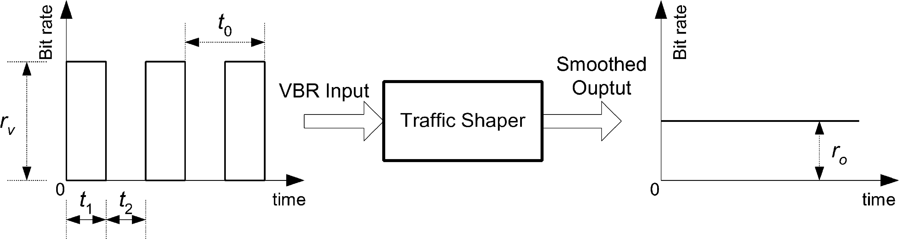
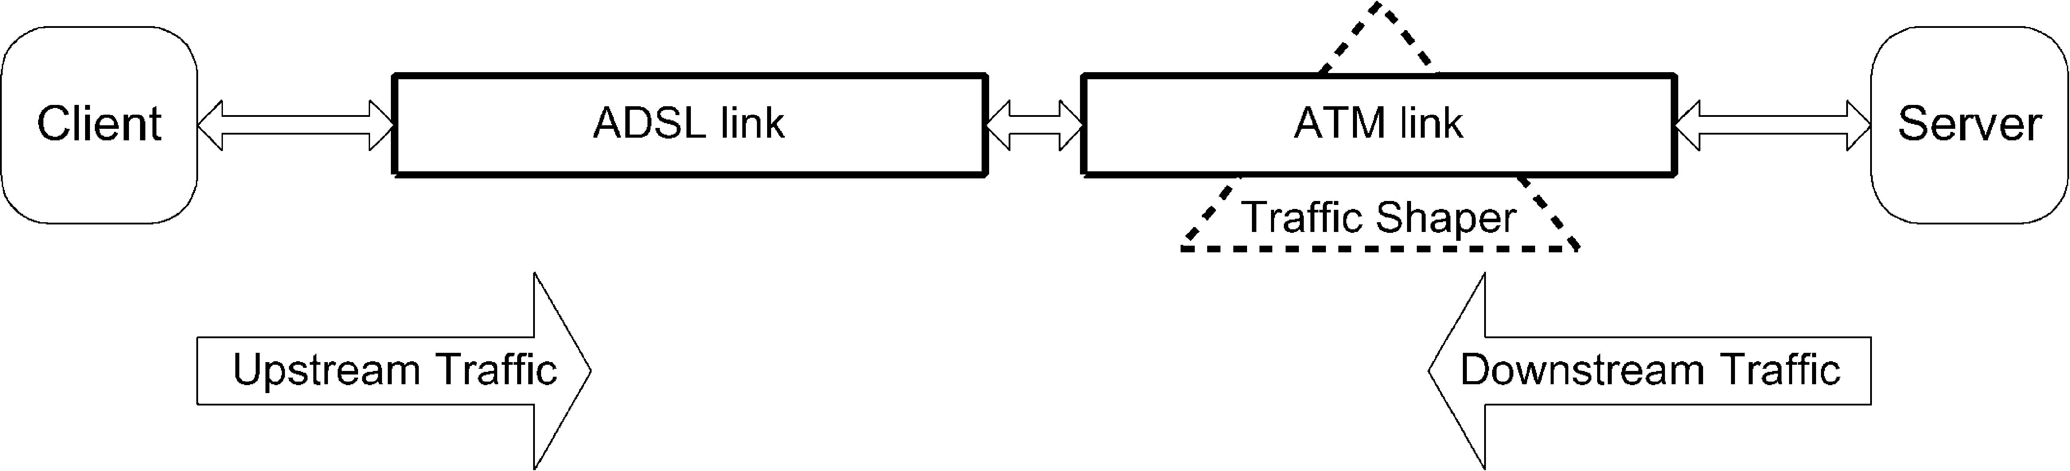

1702

L. Cheng, I. Marsic / Computer Communications 25 (2002) 1699–1710

Fig. 2. Trafﬁc shaping illustration diagram.

In general, different service categories are
implemented through different queues in an ATM
switch. Buffering method deﬁnes the amount of buffer
space available to a given queue and speciﬁes how the
space is shared among the different queues. In the
Complete Partitioning scheme, each queue gets a ﬁxed
amount of the buffer space while in the Complete
Sharing scheme, all buffer space is fully shared among
all the queues. As a compromise between the two
schemes, the Sharing with Minimum Allocation scheme
reserves a minimum buffer space for each queue while
the rest of the buffer is completely shared among the
queues [19]. Commercial ATM implementations favor
buffer sharing schemes because of lower memory
requirements, e.g. Cisco LightStream 1010 with total
buffer capacity of only 64K cells [18].
Fig. 2 and the following discussion adapted from Ref.
[19] illustrates that the amount of the buffer space in the
ATM trafﬁc shaper is a major factor in determining if and
when cell loss occurs. If we denote the input trafﬁc rate r_{v}as
positive and the output trafﬁc rate r_{o}as negative values in
Fig. 2, the sum of the averages of the input and output trafﬁc
rates, r, which is denoted in Eq. (1), will determine the cell/
packet loss
2.2. Effects of ATM trafﬁc shaping on bandwidth
measurement

The network model for bandwidth measurement is
shown in Fig. 3. The ADSL service rates are independent
of the ATM service categories chosen. The ADSL service
rates are chosen by using different line cards on the ATU-C
unit. We assume that the ADSL link is always the bottleneck
link since ATU-R, e.g. ADSL modems, will accommodate
ATM transport with variable rates and compensation for
ATM overhead [2]. The bearer channel of ADSL interface
can be programmed to carry bits in any multiple of 32 Kbps.
For example, when ADSL is used for downstream ATM cell
transport, service rates of 1.760, 3.488, 5.216, and
6.944 Mbps are the options. The odd-looking speeds are a
result of the desire to preserve compatibility with existing
AAL1 and circuit deﬁnitions already entrenched in ATM
speciﬁcation. ADSL service rates that are not simple
multiples of 32 Kbps can be supported by carrying ‘extra’
bits in the shared overhead area of ADSL frame [9].
Therefore, the measured bandwidth in a general case is the
nominal value of the ADSL service rate since the ADSL link
is the bottleneck.
However, ADSL link bandwidth can sometimes be larger
than the ATM link bandwidth because of the following

r ј r_{o}ю r_{v}рt₁=t₀Ю
р1Ю
reasons: (i) the characteristics of a copper telephone line
vary over time, even from daylight to night time, due to

The variables t₁and t₂deﬁne the ON and OFF periods
of the ON/OFF VBR trafﬁc ﬂow, and t₀ј t₁ю t₂(Fig.
2). If r is positive, it means that the trafﬁc shaper
receives data at a greater rate than it can deliver, and
thus the cell/packet loss will eventually occur. If it is
zero or negative, a zero loss can be achieved by
buffering the cells during the bursty period t₁, and the
amount of data that must be buffered is t₁(r_{v}ю r_{o}). In
this case some cells will be delayed.
temperature, other trafﬁc in the same cable bundle, and
external RF interferences [10]; and, (ii) the matching
difference between the rate of the bearer channel of ADSL
interface and the rate of the ATM switch. In these cases, the
ATM link will be the bottleneck link. However, because
both the ADSL service rate and ATM bit rate are supposedly
conﬁgured to be the same, the measured bandwidth still
represents the nominal value of the ADSL service rate.
In the cases of downstream trafﬁc or upstream trafﬁc with

Fig. 3. Network model for bandwidth measurement.

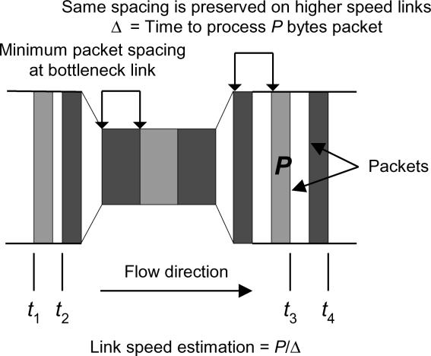

L. Cheng, I. Marsic / Computer Communications 25 (2002) 1699–1710

1703

Fig. 4. Packet-pair technique for bandwidth measurement (adapted from
Ref. [15]).
ATM bit rate being lower than the ADSL service rate, the
ATM trafﬁc shaping mechanism may introduce inaccuracies
in bandwidth measurement. Bandwidth measurement tech-
niques, such as pathchar in Ref. [11], send a large number of
probe packets without explicit trafﬁc regulation, which

hundred for each measurement, while the number of packets
used by other currently available bandwidth measurement
tools [16] is of the order of a thousand. Thus our scheme is
lightweight in terms of implementation complexity and
probe trafﬁc overhead. We ﬁrst describe the packet-pair
technique and then present the multi-packet technique.

3.1. Packet-pair technique

The packet-pair technique for bandwidth measurement is
based on FIFO queuing network model. Various forms of
the packet-pair technique are studied by Bolot [3], Carter
and Crovella [4], Paxson [20], and Lai and Baker [17]. Its
essential idea is using inter-packet time to estimate the
characteristics of the bottleneck link. If two packets, e.g.
Internet Control Message Protocol (ICMP) probe packets,
travel together so that they are queued as a pair at the
bottleneck link with no packet intervening between them,
then their inter-packet spacing is proportional to the
processing time required for the bottleneck link to transmit
the second packet of the pair (Fig. 4). Therefore the link
bandwidth of the bottleneck link, b, can be computed as:

subjects them the ATM trafﬁc shaping. The shaper either
delays the packets or overﬂows and causes some probe
b ј P=D
р2Ю

packets to be dropped. The phenomenon is similar to the
scenario where for some service classes, such as the CBR
where P is the packet size. Note that the inter-packet spacing
at the source must be sufﬁciently small so that:

service, an increase in the data rate beyond the provisioned
bandwidth may result in heavy packet loss caused by the
ATM trafﬁc shaping. The effect on the bandwidth
measurement is distorting the results since the accuracy of
those techniques depends on timely delivery of the probe
t₂2 t₁# P=b ј t₄2 t₃
and
D ј t₄2 t₃
р3Ю

р4Ю

trafﬁc.
To minimize the effect of ATM trafﬁc shaping, we
designed a stepwise bandwidth measurement algorithm. In
the ﬁrst step, a few packets (with the total size less than
10 KB) are used to get the trial bandwidth of the xDSL link.
No packet loss is expected because the buffer in ATM
switches is generally big enough to tolerate a small burst.
The discussion in Ref. [15] about the measurement agility
implies that such small amount of data is suitable to get a
rough estimate of the nominal bandwidth. Then in the
following steps a relatively large number of packets are used
for results convergence and consistence. The packets are
generated from a smooth trafﬁc generator so that most of
them are not dropped by the ATM trafﬁc shaper.

3. Multi-packet bandwidth measurement

Our bandwidth measurement scheme uses a multiple
packet technique instead of two packets in the packet-pair
technique in order to achieve accuracy of the measurement,
without deploying explicit packet-ﬁltering techniques [16].
Our experience shows that the number of probe packets
required to achieve accurate measurement is on the order of
We generalized this technique to a multi-packet technique
and applied it to achieve accurate bandwidth measurement
in xDSL networks, including ADSL networks.

3.2. Multi-packet technique

Since packet-pair methodology depends on the correct
inter-packet time, two factors could diminish the accuracy
of measurement results [16]. One is called time com-
pression, where the ﬁrst packet of the packet pair gets
delayed because of some other cross trafﬁc along the
measurement path and the time interval of the packet pair is
decreased. Thus the result will be larger than the actual
bandwidth. The other is called time extension, where the
second packet of the packet-pair gets delayed and the time
interval is increased. Thus the result will be smaller than the
actual value. The packet loss in the packet-pair falls in the
latter case. Packet-pair ﬁltering algorithms [16] can be
applied to handle these cases so that inaccurate packet-pair
time intervals are ﬁltered out and the measurement results
become more accurate.
In xDSL networks, customers and administrators use our
tool as a network testing or monitoring tool. The data path
from the end-user’s computer to the bandwidth measure-
ment server is an ATM-circuit-like path. It is safe to assume

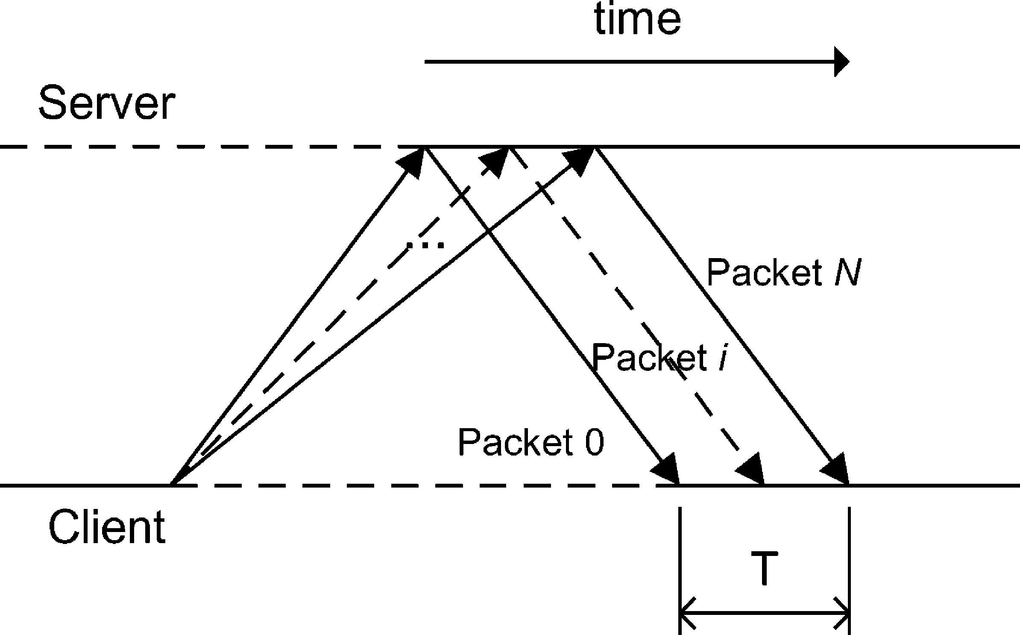
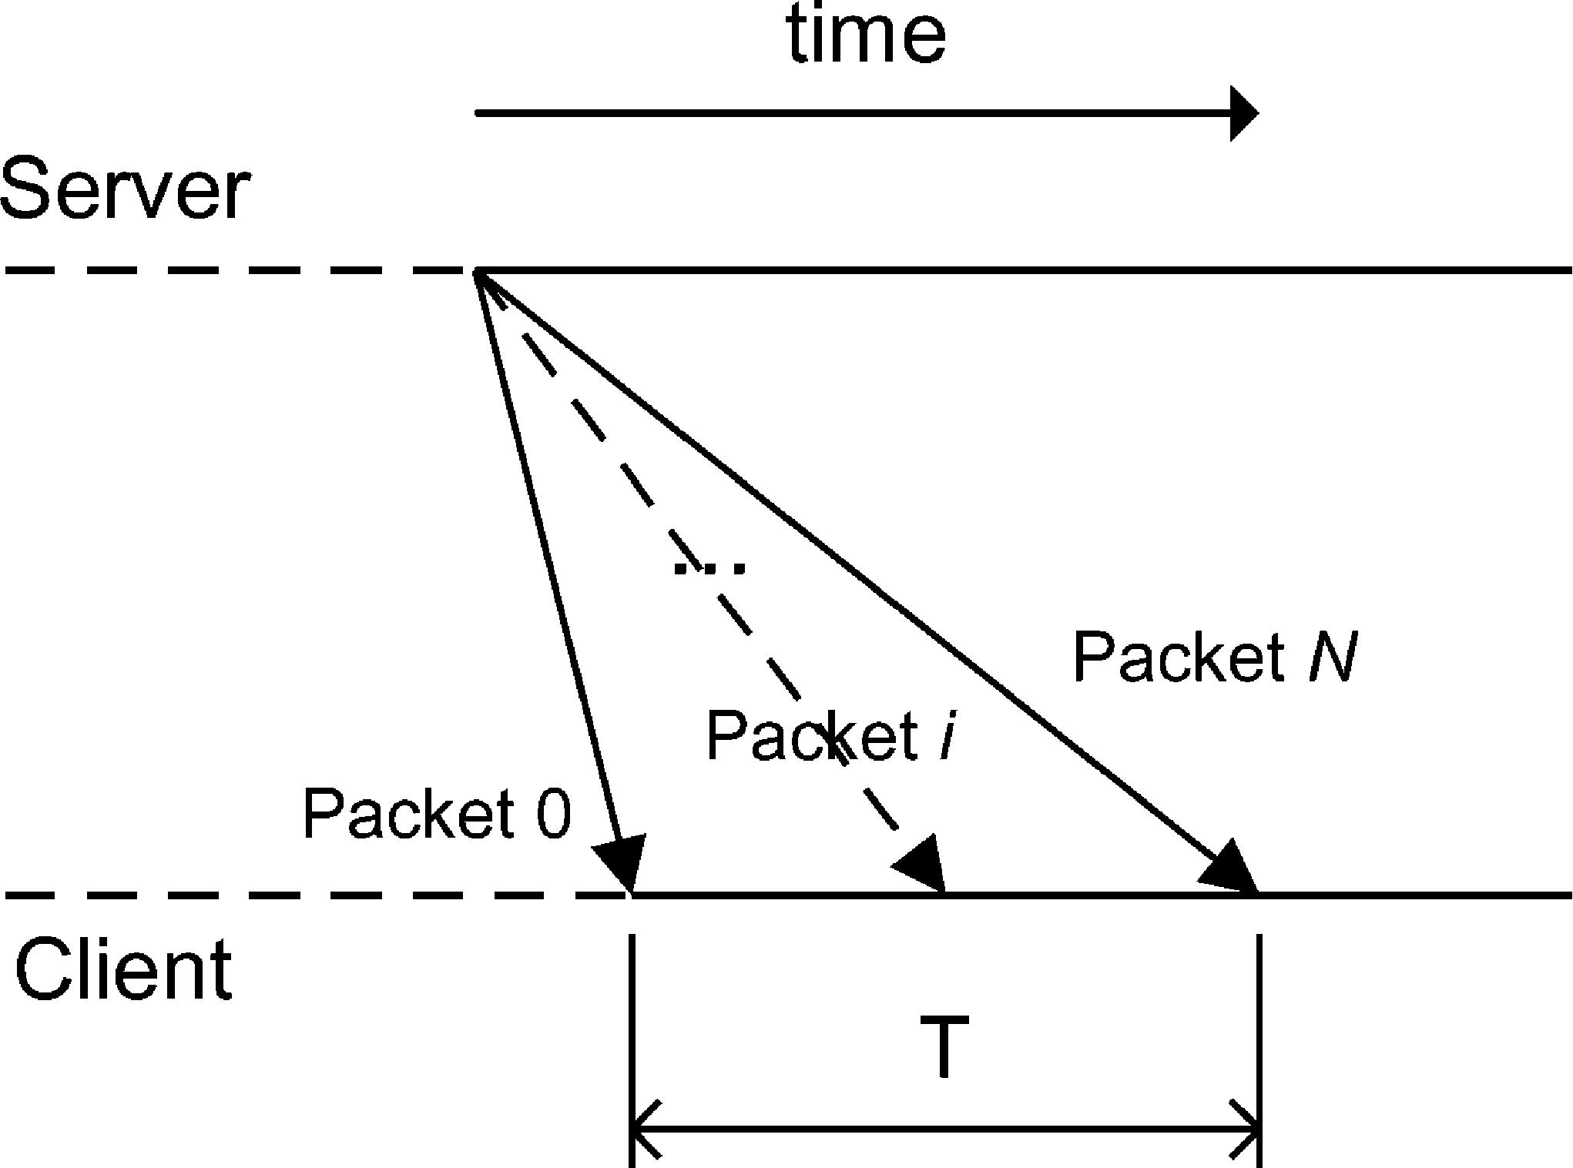

1704

L. Cheng, I. Marsic / Computer Communications 25 (2002) 1699–1710

packets are simultaneously sent, no packet will be dropped
by the ATM trafﬁc shaping. The ﬁrst step in our stepwise
algorithm conforms to Theorem 1 by using a very small
number of packets. The algorithm is presented in Section 4
below.
The condition of sending the packets at the same time can
be relaxed if the time interval between consecutive packets
is not greater than the time required to transmit a packet
over the bottleneck link. This is illustrated in Fig. 4, where
the inter-packet spacing after the bottleneck link does not

Fig. 5. Upstream multi-packet bandwidth measurement.
that there is no cross trafﬁc, meaning that time compression
is not a problem in our case. However, time extension may
occur due to ATM trafﬁc shaping in xDSL service and due
to possible packet loss. Hence, we apply a maximum
operator to handle the inaccuracy caused by time extension.
In order to reduce the effect of time extension, we
propose to use multiple packets instead of two packets in
packet-pair to conduct the bandwidth measurement. The
multi-packet technique does not need to deploy explicit
packet ﬁltering in order to achieve accurate measurement
because of its intrinsic ﬁltering due to the averaging of
results over the multiple packets. Theorem 1 provides the
foundation for the multi-packet technique.

Theorem 1. Multi-packet bandwidth measurement. Let
b_{min}# b_{i}р;i; 1 # i # mЮ; where m is the number of links in
the path and b_{i}is bandwidth of the i-th link between the node
i 2 1 and the node i. Then if multiple, N ю 1, packets of the
same size рs₀ј s₁ј · · · ј s_{N}ј sЮ are sent at the same time
рt₀ј t₁ј · · · ј t_{N}Ю and there is no packet drop and no
cross-trafﬁc along the path, they will arrive with a difference
in time equal to the sum of all packet sizes divided by the
smallest bandwidth along the path, i.e. t_{N}рmЮ 2 t₀рmЮ^{ј}
рs Ј NЮ=b_{min}; or b_{min}ј рs Ј NЮ=рt_{N}рmЮ 2 t₀рmЮ^{Ю}; where t_{j}(‘)^{is}
the time when packet j fully arrives at node ‘.

Using results from Ref. [16], we prove Theorem 1 in
Appendix A.

3.3. Discussion

Theorem 1 assumes that there is no packet drop, which
means that N should be small enough to ensure that when N

Fig. 6. Downstream multi-packet bandwidth measurement.
depend on the inter-packet spacing before the bottleneck
link, as long as the latter is smaller. This is also stated in Eq.
(3). In the second and subsequent steps of the stepwise
algorithm, a smooth trafﬁc generator sends the packets with
the inter-packet intervals such that the rate is slightly higher
than the bottleneck link bandwidth estimated in the ﬁrst
step. Therefore, Theorem 1 still holds valid.

3.4. Application to asymmetric DSL

The asymmetric nature of the ADSL network makes it
necessary to have different measurement methodologies for
upstream and downstream cases. The design is based upon
the assumption that the upstream bandwidth is lower than
the downstream bandwidth.

3.4.1. Upstream methodology
A ﬁxed number, N ю 1, of UDP packets of uniform size,
P bytes, are sent from the customer’s computer (client) at a
rate slightly higher than the nominal bottleneck bandwidth
of the ADSL network. Probe trafﬁc with a slightly higher
rate (about 10%) is necessary to saturate the pipe. A server
process on the Bandwidth Measurement Server (Fig. 1),
echoes back the packets as they arrive at the server end. Fig.
5 shows this scheme. The time difference, T, is measured
between the arrival of the ﬁrst packet and the last packet at
the client end. The upstream bottleneck link bandwidth, b₁,
is computed as:

b₁ј рN Ј P Ј 8Ю=T ЅKbps р5Ю

3.4.2. Downstream methodology
A trafﬁc generator at the Bandwidth Measurement Server
generates a downstream trafﬁc. A receiving process at the
client measures the arrival time of the packets. Because of
the nature of ADSL, such that the upstream bandwidth is
smaller than the downstream bandwidth, the client does not
echo the probe packets back. Instead, the client computes
the downstream bandwidth using the same Eq. (5) as for the
upstream case. Fig. 6 shows the downstream scheme. The
downstream method can be used for the upstream case, but
the results should then be sent from the Bandwidth
Measurement Server back to the client for display.

L. Cheng, I. Marsic / Computer Communications 25 (2002) 1699–1710

1705

Table 1
Pseudo-code for the simple trafﬁc generator
//Initialize:
//maxNumOfPackets is the maximum number of packets
allowed to be sent
//packetSize is the size of packet in bits, rate is the
expected trafﬁc rate
delay ј packetSize/rate;

for (k ј 0; k , maxNumOfPackets; kю ю)
{
sleep(delay);
sendPacket();
}

4. Stepwise bandwidth measurement algorithm with
smooth trafﬁc generator

4.1. Stepwise bandwidth measurement algorithm

Our stepwise algorithm consists of at least two steps. It
can be used for both downstream and upstream measure-
ments described in Section 3.4. The generated trafﬁc should
be smooth rather than bursty to avoid excessive ATM trafﬁc
shaping. We run the stepwise algorithm several times and
report the maximum measured value as the link bandwidth.
During the ﬁrst step, a small number of packets, e.g. 10,
Table 2
Pseudo-code for the new trafﬁc generator

//Initialize:
//maxNumOfPackets is the maximum number of packets
allowed to be sent
//packetSize is the size of packet in bits, rate is the
expected trafﬁc rate
//pps: the number of packets to be sent per second
pps ј rate/packetSize;
fraction ј 0;
stopSleep ј getTimeMillis(); //get the current time in
ms
startSleep ј stopSleep;
i ј 0; //number of packets have been sent
do
{
sleep(1); //sleep for 1 ms
stopSleep ј getTimeMillis();

packetCount ј (int) (fraction ю pps * (stopSleep 2
startSleep)/1000);

are sent sequentially back-to-back from the client to the
server. This small number of packets will not likely be
affected by ATM trafﬁc shaping, as most ATM networks are
capable of handling such small bursts. The computed result
is used in the second step as the trial bandwidth of the xDSL
link.
The subsequent step(s) assumes that the accurate xDSL
bandwidth is close to the trial result obtained from the ﬁrst
step. A larger number of packets than that in the ﬁrst step are
used in the measurement to ensure that the results are
convergent and in the end consistent. Had it not been for the
ﬁrst step that approximately determined the bandwidth, the
sustained higher-than-provisioned trafﬁc would result in a
considerable loss or queuing delay caused by ATM trafﬁc
shaping, and this would deteriorate the results, as explained
in Section 2.2 earlier.

4.2. Smooth trafﬁc generator

As discussed in Sections 2.2 and 3.3 above, the accuracy
of the bandwidth measurement depends on whether the
trafﬁc generator can generate a smooth trafﬁc at a rate
slightly higher than or equal to the nominal bottleneck
bandwidth of the xDSL network, thus it is crucial to
implement an accurate and stable trafﬁc generator with
smooth trafﬁc ﬂow.
A straightforward method of generating packets at a
known rate employs the algorithm shown in Table 1.
While the above pseudo-code seems to be correct in
theory, it does not yield the expected behavior. Owing
to the scheduling mechanisms of operating systems and
coarse granularity of timers, the packets are not
necessarily sent at the required rate with uniform
spacing. Consider the case when the call to sleep()
returns and the process is scheduled out. Instead of
sending a packet immediately, the packet is sent only
when the OS reschedules the process. This results in
data rate oscillations or bursts in trafﬁc generating,
which is shown in Section 4.3 later.
To overcome the randomness caused by the scheduling
mechanisms of operating systems and coarse granularity of
timers, we devised an alternative way of generating smooth
trafﬁc at the desired rate. The pseudo-code for the improved
algorithm is shown in Table 2. The algorithm achieves the
stable and smooth trafﬁc ﬂow by adjusting the trafﬁc nearly

fraction ј (fraction ю pps
*
(stopSleep 2
every millisecond. It is similar to the leaky bucket algorithm;

startSleep)/1000) 2 packetCount;

startSleep ј stopSleep;
upLimit ј i ю packetCount;
if(upLimit . maxNumOfPackets)
upLimit ј maxNumOfPackets; //reached the maximum
number of packets allowed to be sent
for (; i , upLimit; iю ю)
sendPacket();
} while(i , maxNumOfPackets);
see, e.g. Section 13.3.4 in Ref. [13]. Intuitively, for every
millisecond the trafﬁc generator accumulates tokens into
packetCount, which is a real number, e.g. 1.3. The
algorithm checks the packetCount every millisecond
and the integer part represents the number of packets to be
sent (if greater than zero). The remainder, called frac-
tion, e.g. 0.3, is then used in the next millisecond’s
accumulation. The performance of the new trafﬁc generator
is shown in Section 4.3.

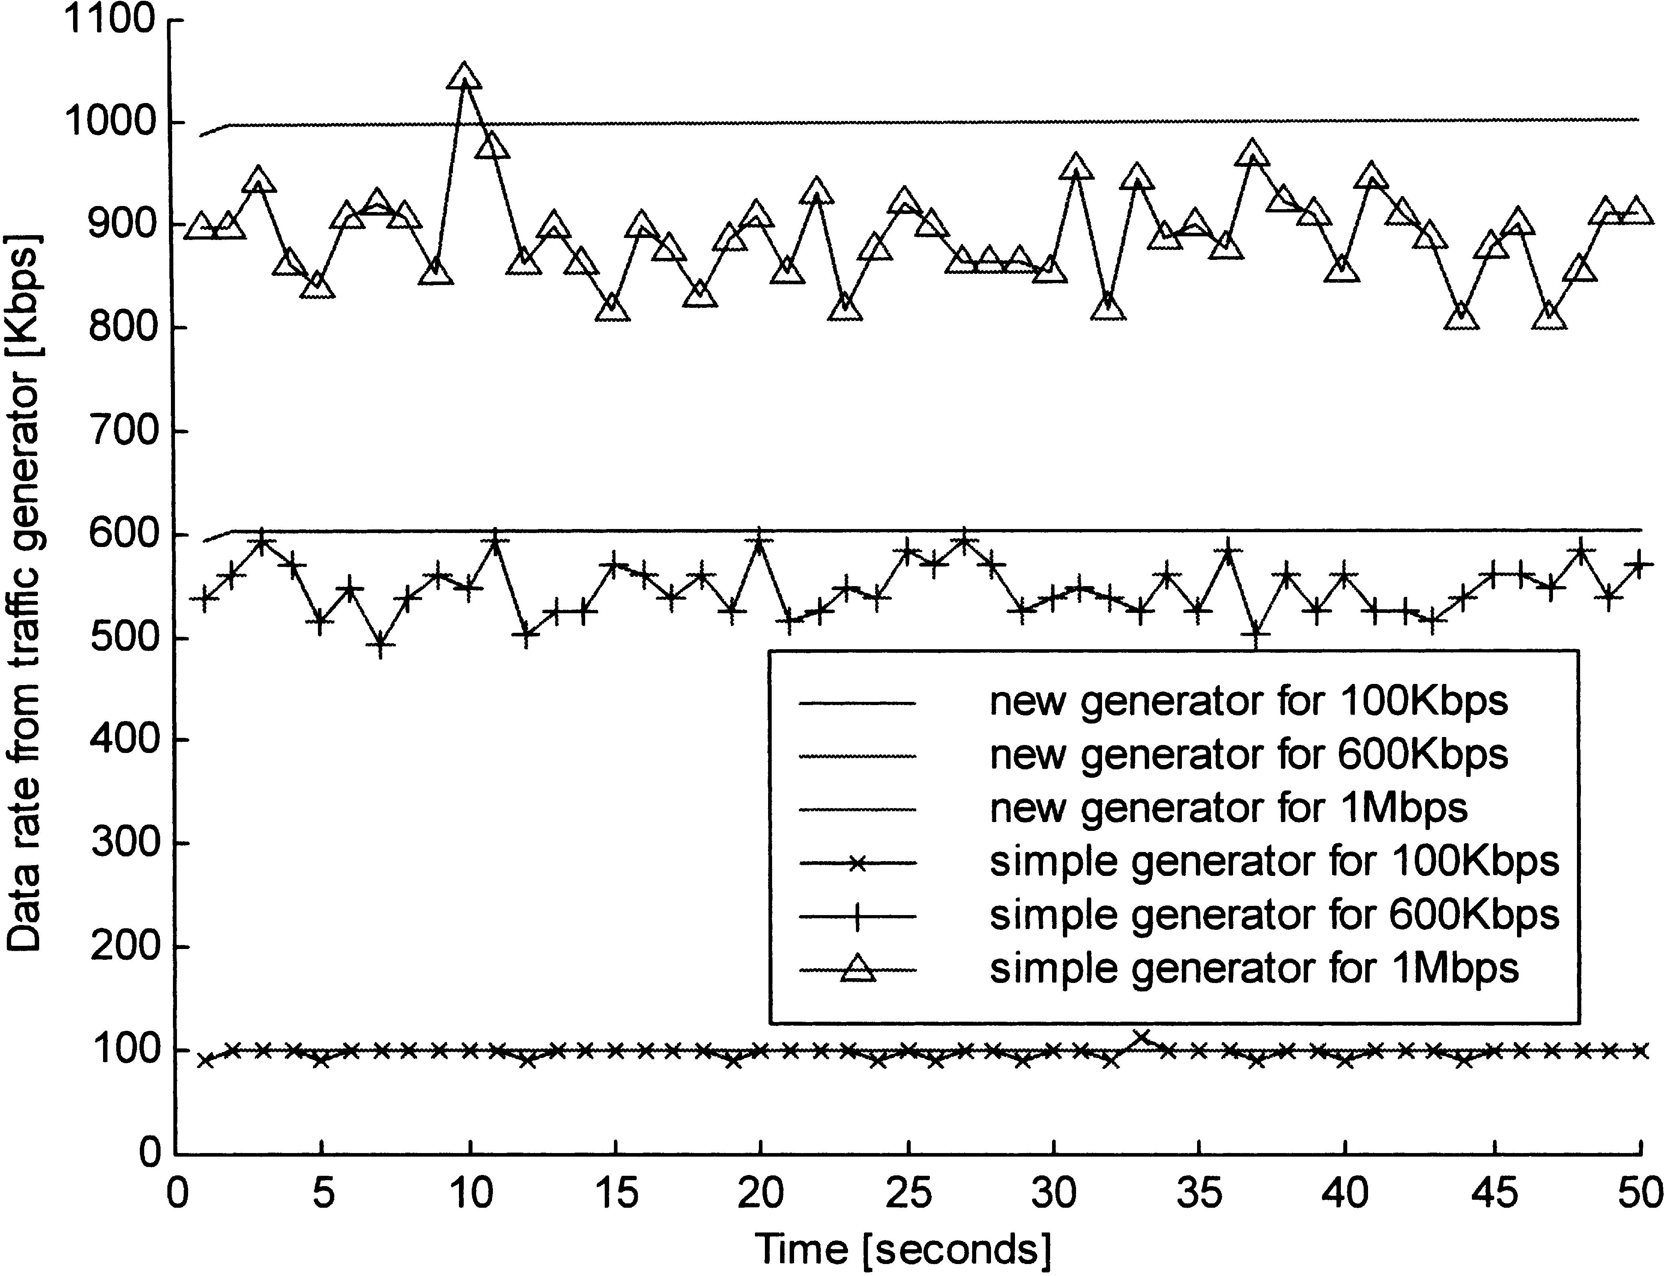

1706

L. Cheng, I. Marsic / Computer Communications 25 (2002) 1699–1710

Fig. 7. Performance comparison for trafﬁc generators. The parameters used in simulation are: a ј 1; b ј 10:

The packet size is computed as:
P ј MAC header ю IP header ю UDP header ю payload
р6Ю
The default payload size is 1400 bytes for packets to ﬁt the
Ethernet frame size. The payload is a ZIP-compressed ﬁle to
avoid the effects of the compression on the V90 analog
modem.

4.3. Performance study of the trafﬁc generator

We simulated in Matlab both the simple trafﬁc generator
caused by the scheduling mechanisms of operating
systems.
3. The randomness caused by the coarse granularity of
timers is multiplicative because it is accumulated by each
tick of the timer, and it is limited to a certain range. For
example, in case a thread is set to sleep for tsleep
milliseconds, the actual time the thread will sleep, tdelay,
can be expressed as:

tdelay^{ј}tsleep^{ю}Rtimer р8Ю

where

(Table 1) and our original trafﬁc generator (Table 2) and
compared their performance in terms of stability and
Rtimer^{ј}SgnрR_{n}ЮMinрAbsрRoundрtsleep^{R}n^{ЮЮ}; bЮ
р9Ю

accuracy. The simulation models can be expressed as
follows:

1. Physical network interface of the data source is 10/
100 Mbps Ethernet, which is popular in xDSL
implementation with PPPoE (Point-to-Point Protocol
over Ethernet).
2. The randomness caused by the scheduling mechanisms
of operating systems is additive and limited to a certain
range. For example, since the minimum time used to send
a packet of 1400 bytes is t_{min}milliseconds рt_{min}ј
1400 Ј 8 Ј 1000=10⁷in case of the 10 Mbps Ethernet),
the actual time used to send a packet tsend can be
expressed as:
where Sgn(·) is the signum function, Abs(·) is the
absolute value function, Min(·) is the minimum value
function, and b(b . 0) is the upper limit on the random
value caused by the coarse granularity of timers (in ms).

The simulation results are shown in Fig. 7. The data rate
from the new trafﬁc generator is stable and smooth.
Compared to the oscillations and deviations in trafﬁc rate
generated by the simple trafﬁc generator, the new generator
has much better performance than the simple one. The new
trafﬁc generator is an essential part of our accurate
bandwidth measurement scheme.

tsend^{ј}Roundрt_{min}ю R_{os}Ю
р7Ю
5. Evaluation

where R_{os}ј aR_{n}; R_{n}is a uniformly distributed real
random number on [0,1), Round(·) is an operator that
rounds a number towards the nearest integer, and a is the
upper limit (in ms) of the additive random component
We have implemented the above bandwidth measure-
ment scheme as a Java-applet based tool and deployed it in a
commercial setup [5]. We ﬁrst evaluated the tool using a
serial link in a laboratory testbed network in which the

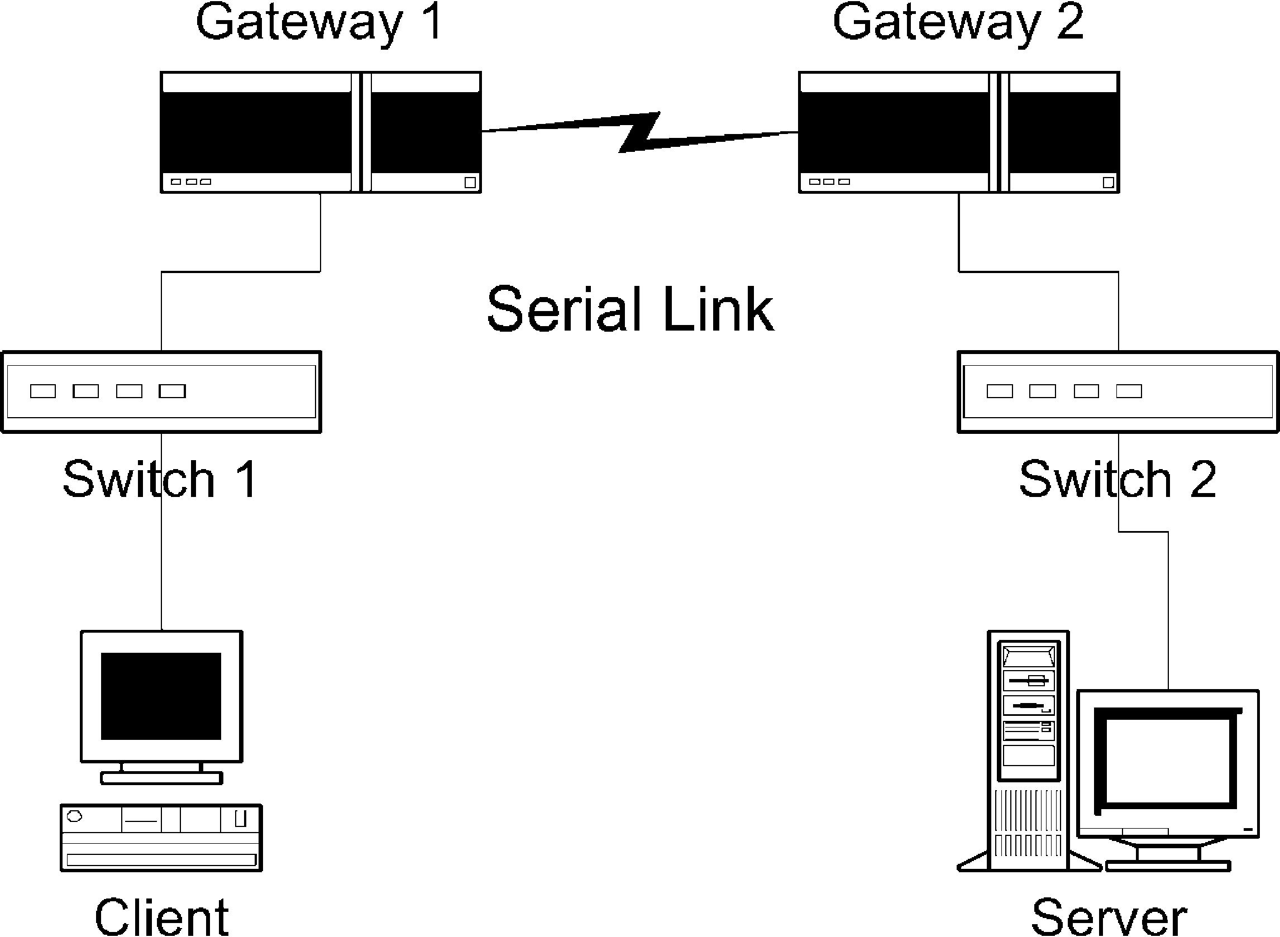
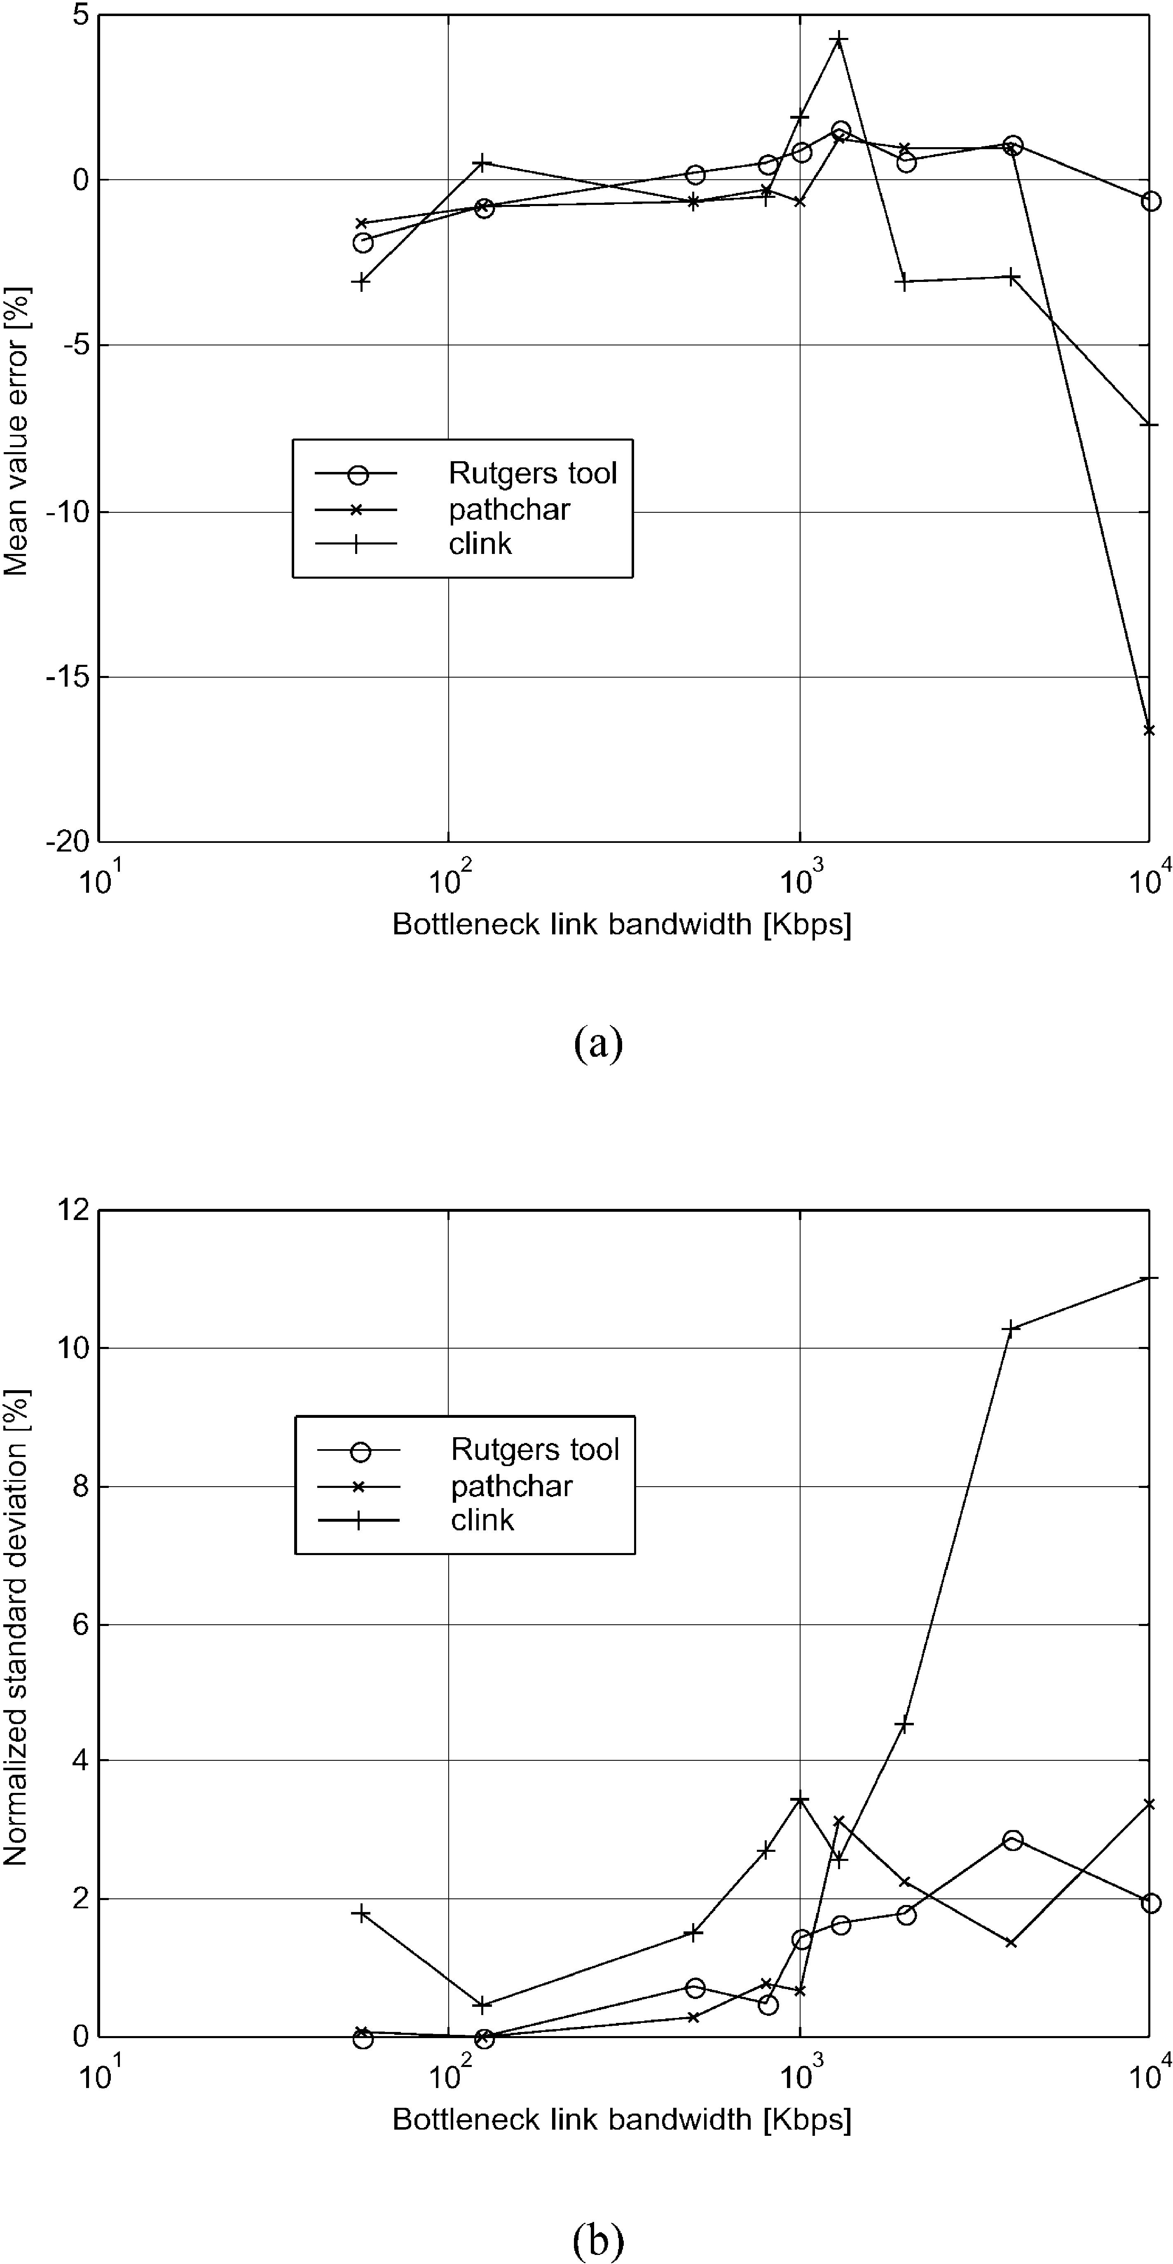

L. Cheng, I. Marsic / Computer Communications 25 (2002) 1699–1710

Fig. 8. Testbed topology.
bandwidth could be altered manually. Next, we evaluated
the tool over commercial ADSL service networks.

5.1. Laboratory experiments

Fig. 8 shows the topology of the testbed. The client and
the server are in different subnets that are connected by a
serial link by introducing a High-Speed Serial Interface
(HSSI) between the two gateways. The serial link is the
bottleneck link. The endpoints for the tests were located
across the two ends of the HSSI. There is no cross trafﬁc.
We compared our measurement tool with other popular
tools, such as pathchar [7,11], clink [8], and nettimer [14].
The experiments were performed on an Intel Pentium II
266 MHz machine with Red Hat Linux 7.2 installed. For a
certain bandwidth setting of the HSSI, the test was repeated
100 times for the Rutgers tool which generates measurement
results in seconds, and 10 times for both pathchar and clink
which generate results in minutes, as illustrated in Table 3.
The test was also repeated 10 times for the nettimer tool for
several parameter and HSSI bandwidth settings. The results

1707

were generated within seconds or minutes, depending on the
nettimer parameter settings.

5.1.1. Rutgers tool vs. pathchar and clink
Table 3 shows the experimental results for the case of
10 Mbps link. Both pathchar and clink use ICMP packets in
estimating the link characteristics. The Rutgers tool is
implemented as a Java applet which uses UDP packets and it
is thus platform-independent and very easy to use. Unlike
pathchar and clink, no root or super-user privileges are
required to use our tool.
Fig. 9 compares the performance of our bandwidth
measurement tool to that of pathchar and clink on a range of
bottleneck link bandwidths. The ﬁgure shows that our tool
compares favorably with the other tools in terms of
measurement accuracy. In addition, it is much faster to
run, consumes much less bandwidth, and it is platform
independent. Both pathchar and clink show signiﬁcant
deterioration of measurement accuracy starting at about
10 Mbps. We did not perform measurements for higher
bandwidths, but it is reported in Ref. [16] that the accuracy
becomes worse with increasing bandwidth.
Fig. 9. Comparison of tools for bandwidth measurement. The HSSI clock is
only able to accurately set the link speeds up to 4000 Kbps. Consequently
there is a gap from 4000 to 10 000 Kbps, which is the link speed for a
10 Mbps Ethernet LAN.
5.1.2. Rutgers tool vs. nettimer
Nettimer version 2.3.8 was used in the tests. It was run in
the mode that actively probes the bottleneck link bandwidth
by sending a given number of TCP FIN packets to ports on
the destination host. These packets cause TCP RESET
packets to be sent back to the measurement host so that
nettimer captures these packets and makes calculations.
Table 4 illustrates the measurement results. For each
HSSI bandwidth setting, the nettimer was tested 10 times
with each of these three parameter settings: (1) all
parameters of nettimer were set as default, (2) the probe
packet size active_probing_packet_size was set
as 1500 bytes, and (3) the probe packet size active_
probing_packet_size was set as 1500 bytes, the
minimum number of samples, active_probing_
min_samples, and the maximum number of probe
packets sent, active_probing_max_packets_
sent, were set as 5000. Setting the value of probe packet

1708

Table 3

L. Cheng, I. Marsic / Computer Communications 25 (2002) 1699–1710

Laboratory experiment results in case of a 10 Mbps link

Measurement tool Version
Mean value (Mbps) Standard deviation Number of probe packets Mean time per measurement

Rutgers tool

1.0

9.95

197 Kbps

450ª

0.09 min

Pathchar [7]
Clink [8]
Alpha; April 21, 1997 8.34
1.0; August 14, 1998 9.26
336 Kbps
1.10 Mbps
h 2880^{b}
h 1488
7.50 min
1.33 min^{c}

a The number of probe packets can be conﬁgured. In all experiments reported here, 450 packets have been transmitted for each measurement. This number is
statistically signiﬁcant enough to offset the effect of the system timer inaccuracy.
b_{h}is the number of hops between the two endpoints.
c This time is variable and reaches 8.50 min for smaller HSSI bottleneck link bandwidths.

Table 4
Measurement results using nettimer in active probing mode

Measurement tool

Rutgers tool
Nettimer [14]
Nominal bandwidth

Parameter setting #1
Parameter setting #2
Parameter setting #3
56 Kbps

55.0 Kbps
57.1 Kbps
54.5 Kbps
54.9 Kbps
125 Kbps

124.0 Kbps
133.3 Kbps
122.5 Kbps
133.3 Kbps
500 Kbps

501.2 Kbps
400 Kbps
600 Kbps
600 Kbps
2 Mbps

2.01 Mbps
1.48 Mbpsª
10 Mbps

9.95 Mbps
9.65 Mbpsª

a The data is reproduced from Ref. [15] since we were unable to obtain reasonable results at high-speed rates in our laboratory. In our correspondence with
the author, he indicated that problem probably arises due to the limitation of the timer resolution in our conﬁguration. If that is the case, such sensitivity to timer
resolution is not desirable for general xDSL user community.

size to 1500 bytes is suggested in nettimer manual [14] for
better performance when measuring high bandwidth links
on slow hosts. The minimum number of samples and the
maximum number of probe packets send were set to 5000
since it was observed that the large values ensure the
convergence of the measurement results. The results
demonstrate that our tool has generated more accurate
measurement results in all cases that we were able to
measure. For the high-speed rates we use the results
reported in Ref. [15], where error varies from 3.5 to 7.0%
in the 10 Mbps case, but the results for our tool are still more
accurate (error of 0.5%) as shown in Table 4.

5.2. Field experiments

The ﬁeld experiments were performed in the deployment
abstracted as in Fig. 1. The accuracy of our bandwidth
measurement tool is evaluated in the following ATM
service categories in an ADSL service network:

† Constant Bit Rate (CBR) service category
† Real-Time Variable Bit Rate (rt-VBR) service category
† Unspeciﬁed Bit Rate (UBR) service category

For each category, the upstream and the downstream link
bandwidths are measured for several nominal ADSL service
rates: 90 and 680 Kbps in the upstream case, and 640 Kbps,
1.7 and 7.1 Mbps in the downstream case. Each measure-
ment was repeated 100 times and the mean values and
standard deviations were computed. Figs. 10 and 11 show
that our tool generates accurate results. The standard
deviations are omitted in the graphs but they follow similar
trend as in Fig. 9, never exceeding 5%.
The possible reasons for not achieving 100% accuracy
could be some of those discussed in Ref. [16]. Of those, the
most feasible ones seem to be unreachable nominal values
and the timing resolution of the operating system.¹
To verify the necessity of stepwise algorithm, we also
performed ﬁeld measurements with the single-step algor-
ithm. The experiment explicitly sets the trafﬁc generator’s
sending rate in the client, lets it send sustained trafﬁc at that
rate, and then records the result at the measurement server.
The results show that the measurement inaccuracy of the
single-step algorithm ranges up to 25%. Since the stepwise
algorithm prevents packet loss caused by ATM trafﬁc
shaping in xDSL service networks, it increases the accuracy
of the bandwidth measurement.

6. Conclusion

Telecom operators use xDSL service networks to provide
high-speed digital services by taking advantage of their
copper infrastructure via overlay and without interfering
with the traditional analog telephone service, such as Plain
Old Telephone Service (POTS). Because xDSL is intro-
duced on a per-user basis and has full bandwidth and service
ﬂexibility, it is essential for both customers and xDSL-
service providers to have tools to accurately measure the
xDSL link bandwidth.
We presented a novel stepwise bandwidth measurement

1 In addition to the timer used in trafﬁc generation, there are also times
recorded at the beginning and end of each measurement cycle.

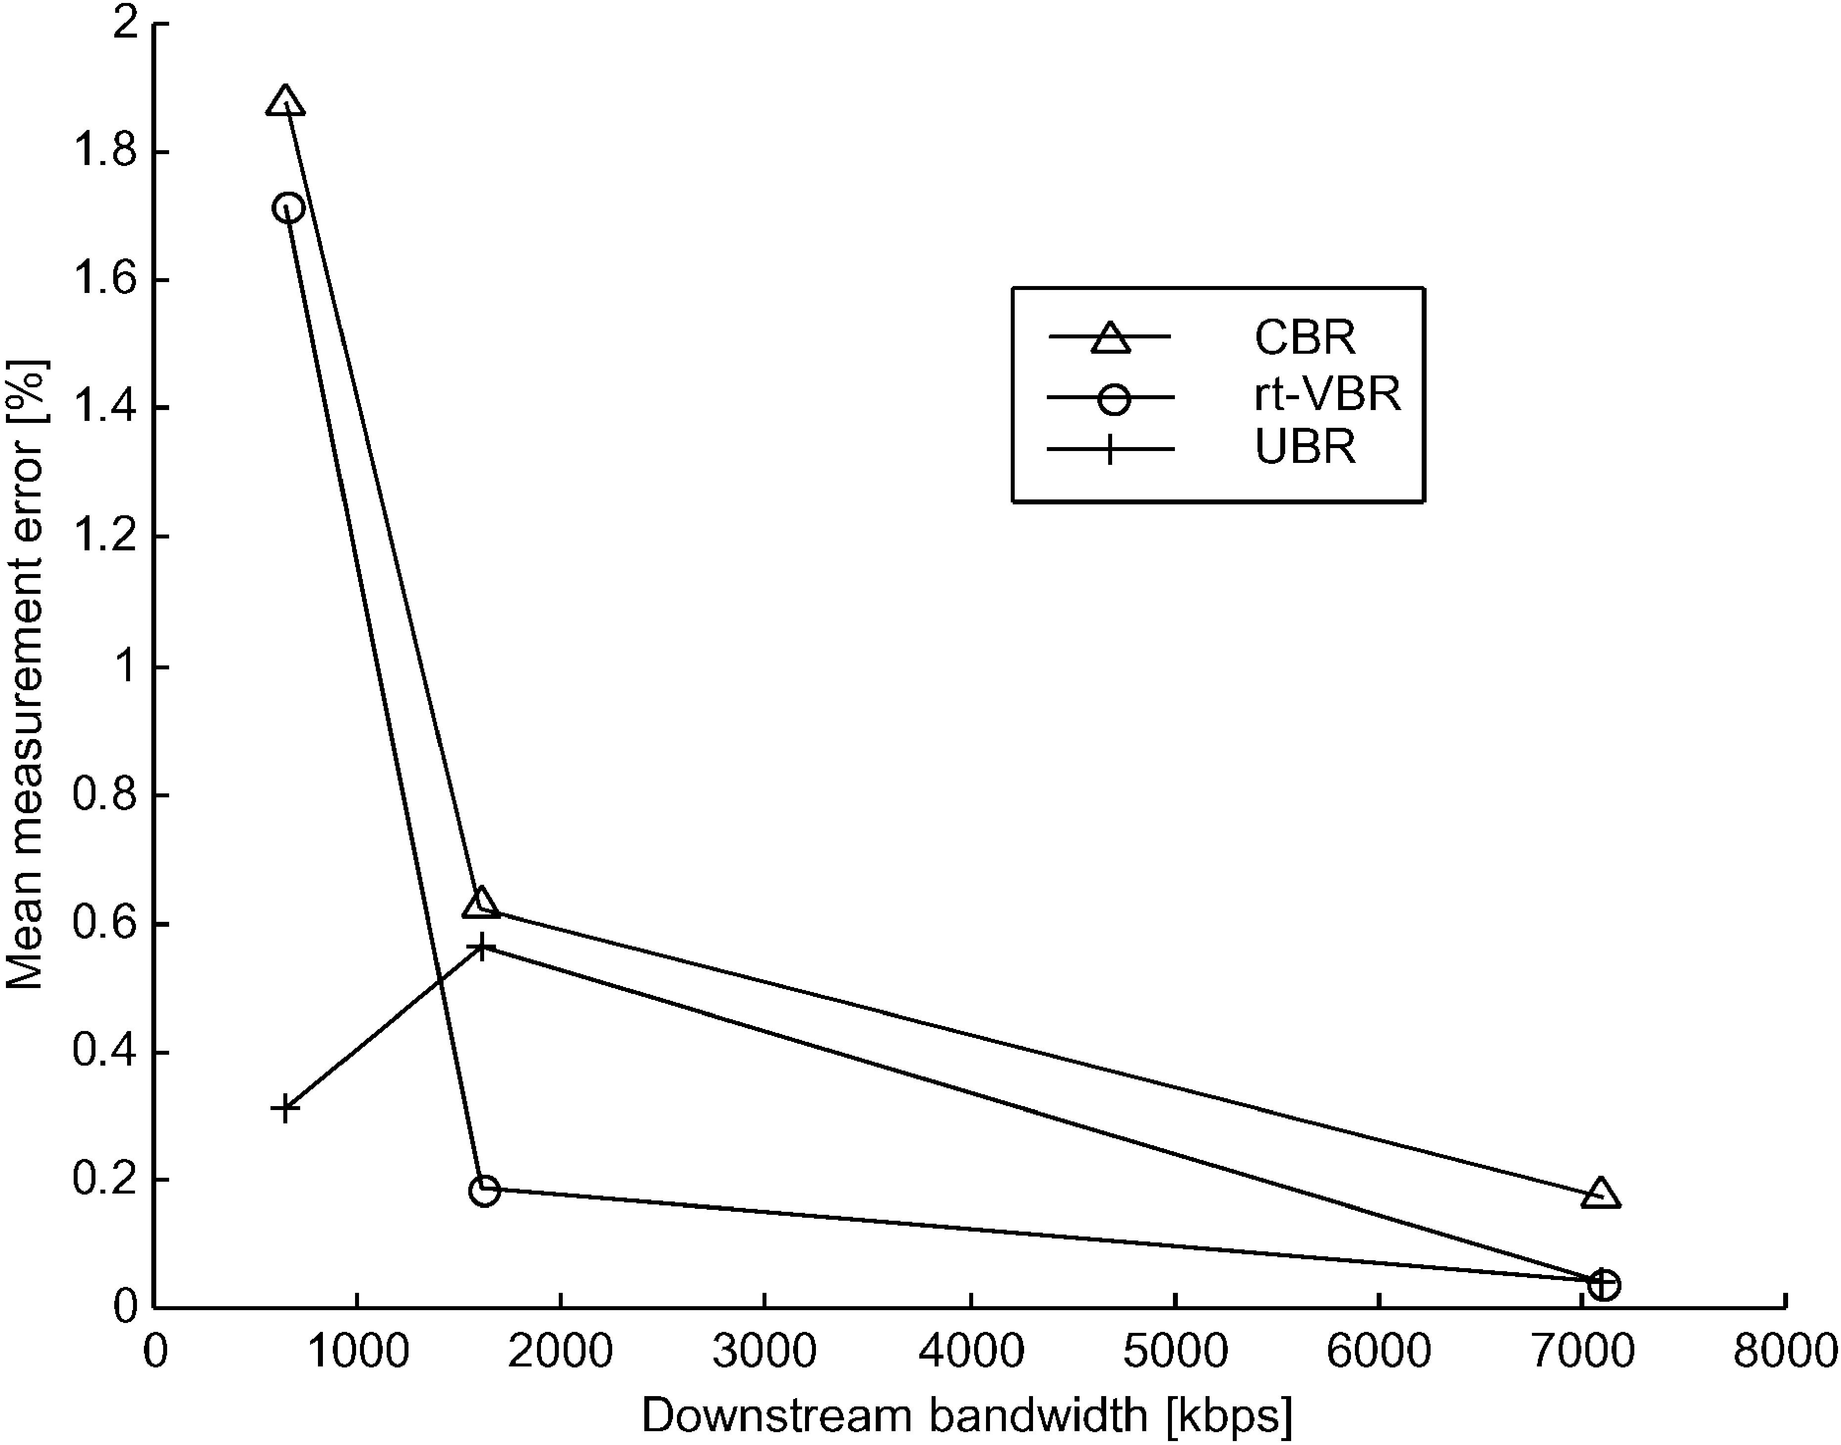
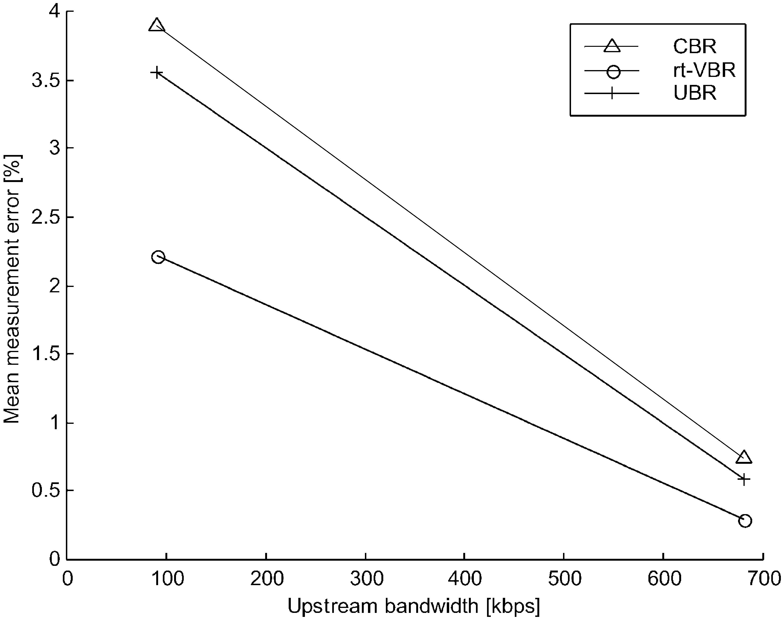

L. Cheng, I. Marsic / Computer Communications 25 (2002) 1699–1710

Fig. 10. Measurement accuracy in ﬁeld experiments of ADSL downstream link.

1709

scheme for accurately measuring link bandwidth in xDSL
service networks, considering the impact of ATM trafﬁc
shaping and link asymmetry. It uses a multi-packet
technique and a smooth trafﬁc generator. The scheme
solves the inaccuracy problem caused by ATM trafﬁc
shaping encountered by bandwidth measurement techniques
that do not regulate their trafﬁc. Given that the ATM shaper
rate is greater than or equal to the ADSL service rate, our
tool measures the actual ADSL link bandwidth. The
deployment of the multi-packet technique does not require
packet ﬁltering to achieve accurate measurements. It is
lightweight in terms of implementation complexity and
probe trafﬁc overhead. Our new trafﬁc generator helps to
achieve the measurement accuracy of the multi-packet
technique.
Evaluation experiments demonstrate that our bandwidth

Fig. 11. Measurement accuracy in ﬁeld experiments of ADSL upstream
link.
measurement tool offers accurate bandwidth measurement
in xDSL service networks. The measurement errors in the
ﬁeld experiments in both upstream and downstream cases
are within the range of 5%, tested in an ADSL network
under the following ATM network conﬁgurations: CBR, rt-
VBR, and UBR service categories. We even plan to further
improve the accuracy of our tool by using the arrival time of
other packets instead of just the ﬁrst and the last packet in
the multi-packet technique. Our future work also includes
more extensive evaluations and embedding this scheme in
network-aware adaptive applications.

Acknowledgements

The authors are grateful to Senthilkumar Rajasekharan
for helping perform the measurements and collecting data in
the ﬁeld experiments. The authors would like to thank
anonymous reviewers and to Dr Edward J. Devinney for
their valuable comments. This research is supported by
grants from Verizon, Inc. (formerly Bell Atlantic), Cisco
Systems, Inc., and NSF KDI IIS-98-72995, and by the
Rutgers Center for Advanced Information Processing
(CAIP).

Appendix A. Multi-packet bandwidth measurement

Proof. We perform induction on N, the number of packet
sent. For N ј 1;

t_{N}рmЮ²t₀рmЮ^{ј}t₁рmЮ²t₀рmЮ

1710

According to Ref. [16],
t_{N}рmЮ 2 t₀рmЮ^{ј}s=b_{min}
that is:
t_{N}рmЮ 2 t₀рmЮ^{ј р}s Ј NЮ=b_{min}

L. Cheng, I. Marsic / Computer Communications 25 (2002) 1699–1710

puter Communications, Cambridge, MA (1999) 241 – 250. August/
September.
[8] A.B. Downey, Clink: a tool for estimating Internet link characteristics,
Wellesley College, Online at: http://rocky.wellesley.edu/downey/
clink/.
[9] W. Goralski, ADSL and DSL Technologies, McGraw-Hill, New
York, 1998.

for N ј 1: This proves the N ј 1 case.
For N . 1, assume the equation holds for N ј n case, i.e.
t_{n}рmЮ²t₀рmЮ^{ј р}s Ј nЮ=b_{min}
then for N ј n ю 1 case,
t_{n}ю1рmЮ 2 t₀рmЮ^{ј р}t_{n}ю1рmЮ 2 t_{n}рmЮЮ ю рt_{n}рmЮ 2 t₀рmЮ^{Ю}
ј рt_{n}ю1рmЮ 2 t_{n}рmЮ Ю ю рs Ј nЮ=b_{min}
According to Ref. [16], since there is no cross trafﬁc,
t_{n}ю1рmЮ 2 t_{n}рmЮ^{ј}t₁рmЮ 2 t₀рmЮ^{ј}s=b_{min}
therefore,
t_{n}ю1рmЮ 2 t₀рmЮ^{ј р}s Ј рn ю 1ЮЮ=b_{min}
This proves the N ј n ю 1 case.

References

[1] ATM Forum, Online at: http://www.atmforum.com/.
[2] DSL Forum, Online at: http://www.adsl.com/.
[3] J.C. Bolot, End-to-end packet delay and loss behavior in the Internet,
Proceedings of the ACM SIGCOMM ’93 Conference on Appli-
cations, Technologies, Architectures, and Protocols for Computer
Communications (1993). pp. 289 – 298 San Francisco, CA, USA.
[4] R.L. Carter, M.E. Crovella, Measuring bottleneck link speed in
packet-switched networks, Technical Report TR-96-006, Department
of Computer Science, Boston University, March 1996, Online at:
http://www.cs.bu.edu/faculty/crovella/papers.html.
[5] L. Cheng, I. Marsic, Java-based bandwidth measurement tool for
digital subscriber line networks, Proceedings of the Ninth Mediterra-
nean Conference on Control and Automation, Dubrovnik, Croatia,
June (2001).
[6] A.B. Downey, From pathchar to netchar: keeping an eye on your ISP,
Presentation at Cisco Systems Inc., Online at: http://rocky.wellesley.
edu/downey/clink/.
[7] A.B. Downey, Using pathchar to estimate Internet link characteristics,
Proceedings of the ACM SIGCOMM ’99 Conference on
Applications, Technologies, Architectures, and Protocols for Com-
[10] D. Greggains, ADSL and high bandwidth over copper lines,
International Journal of Network Management 7 (5) (1997) 277 – 287.
[11] V. Jacobson, Pathchar, 1997, Online at: ftp://ftp.ee.lbl.gov/pathchar.
[12] V. Jacobson, Pathchar—A tool to infer characteristics of Internet
paths, Presented at the Mathematical Science Research Institute, April
21, 1997, Online at: ftp://ftp.ee.lbl.gov/pathchar.
[13] S. Keshav, An Engineering Approach to Computer Networking: ATM
Networks, the Internet, and the Telephone Network, Addison-Wesley,
Reading, MA, 1997.
[14] K. Lai, Nettimer manual, Online at: http://gunpowder.stanford.edu/
~laik/projects/nettimer/#Documentation, last visited and downloaded
on January 15, 2002.
[15] K. Lai, M. Baker, Nettimer: a tool for measuring bottleneck link
bandwidth, Proceedings of the third USENIX Symposium on Internet
Technologies and Systems, San Francisco, CA, March (2001) pp.
122 – 133.
[16] K. Lai, M. Baker, Measuring link bandwidths using a deterministic
model of packet delay, Proceedings of the ACM SIGCOMM 2000
Conference on Applications, Technologies, Architectures, and Proto-
cols for Computer Communications, Stockholm, Sweden, August
(2000) pp. 283 – 294.
[17] K. Lai, M. Baker, Measuring bandwidth, Proceedings of the
Conference on Computer Communications (IEEE INFOCOM ’99),
New York, NY, USA, March (1999) 235 – 245.
[18] A. Lin, LightStream 1010 Switch Architecture and Trafﬁc Manage-
ment, White Paper, Cisco Systems Inc., July 2000, Online at: http://
www.cisco.com/warp/public/cc/so/neso/vvda/atm/lsatm_wp.htm.
[19] T. Lizambri, F. Duran, S. Wakid, Priority scheduling and buffer
management for ATM trafﬁc shaping, Proceedings of Seventh IEEE
Workshop on Future Trends of Distributed Computing Systems
(FTDCS ’99), Cape Town, South Africa December (1999) 36 – 43.
Online at: http://w3.antd.nist.gov/Publications/Hsnt/lizambri_1299.
html.
[20] V. Paxson, Measurements and Analysis of End-to-End Internet
Dynamics, PhD Thesis, University of California, Berkeley, April,
1997.
[21] V. Paxson, End-to-end Internet packet dynamics, Proceedings of the
ACM SIGCOMM ’97 Conference on Applications, Technologies,
Architectures, and Protocols for Computer Communications (1997)
pp. 139 – 152 Cannes, France.
[22] The DSL Forum, Online at: http://www.adsl.com.
[23] R. Wolski, Dynamically forecasting network performance to support
dynamic scheduling using the network weather service, Proceedings
of the Sixth IEEE Symposium on High-Performance Distributed
Computing, August (1997). pp. 316 – 325 Portland, OR, USA.

